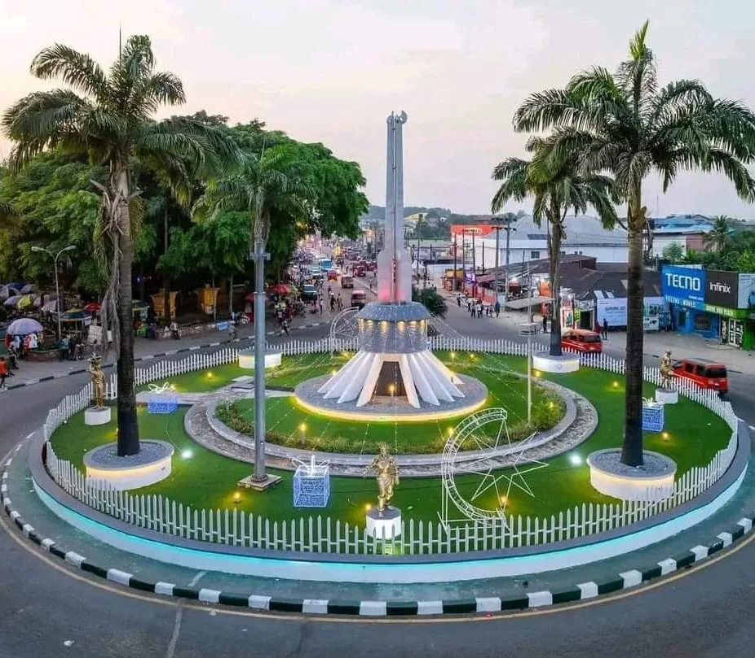

Tourism
Report
  - AKWA IBOM STATE
Created by: Sunday Udo

Contents
Introduction 3
Transportation 6
Accommodations 8
Food & Beverage 10
Recreation & Entertainment 13
Itinerary 17
SWOT Analysis of Tourism in Your Location 20
Conclusion 21

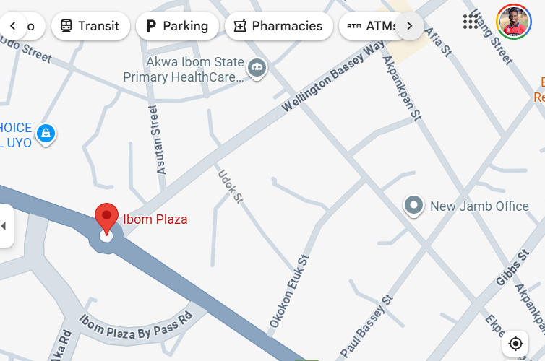
Introduction

AKWA IBOM STATE, NIGERIA
Akwa Ibom State was chosen for its vibrant cultural heritage, stunning beaches, and growing tourism sector, offering insights into eco-tourism, cultural tourism, and hospitality in a developing region.

history
Akwa Ibom State, located in southeastern Nigeria, was created on September 23, 1987, from the former Cross River State by the military administration of General Ibrahim Babangida. The region has been inhabited for centuries by indigenous groups, with evidence suggesting settlements dating back to around 1000 B.C. The major ethnic groups are the Ibibio, Annang, and Oron, who share linguistic and cultural ties within the Benue-Congo language family. These groups were autonomous before British colonial rule, which began in the early 1900s after formal control was established in 1904. The area was part of the Eastern Region post-independence in 1960 and saw significant events during the Nigerian Civil War (1967-1970), where it was contested territory. Tourists might find the colonial history intriguing, including sites like the Amalgamation House in Ikot Abasi, where Northern and Southern Nigeria were united in 1914. Other highlights include the Bridge of No Return in Ikot Abasi, a remnant of the slave trade era, and early missionary influences, such as the first Qua Iboe Church, founded in 1887. This rich tapestry of ethnic diversity and historical landmarks offers visitors a glimpse into Nigeria's pre-colonial and colonial past, blending cultural pride with educational experiences.
.

Weather
Akwa Ibom State features a tropical rainforest climate with high humidity, abundant rainfall, and warm temperatures year-round, averaging 28-30°C (82-86°F). The region experiences two main seasons: a wet season from April to October, with peak rainfall in July (up to 10 inches monthly), and a dry season from November to March, characterized by lower humidity and occasional harmattan winds. During the wet season, heavy downpours can lead to flooding, impacting travel and outdoor activities, while the dry season brings milder conditions ideal for tourism. Peak tourism occurs in the dry season (November-March), when temperatures are comfortable (around 25-32°C or 77-90°F) and rainfall is minimal, attracting visitors for beach outings and festivals. The off-season aligns with the wet months, where humidity reaches 80-90% and storms may disrupt plans. Tourists should avoid July-August due to intense rains, but enjoy December-February for events like Christmas festivals. While hurricanes are rare, tropical storms can affect coastal areas; no major snow events occur. Overall, the climate supports year-round visits with precautions for rain.

tourism
Akwa Ibom State attracts a diverse array of tourists, primarily from within Nigeria and neighboring West African countries, with growing interest from international visitors seeking authentic African experiences. Domestic tourists, often from Lagos, Abuja, and Port Harcourt, visit for short weekends or holidays, drawn by family ties, cultural festivals, and relaxation. International travelers, including Europeans and North Americans, come for eco-adventures and heritage tourism, staying longer—typically 5-10 days—to explore multiple sites. They seek beaches, wildlife, and cultural immersion, with average lengths of stay around 7 days based on resort data in (https://ijeawele.com/akwa-ibom-travel-guide/). Tourist spending contributes significantly to the local economy, with estimates showing the sector generating billions in revenue through accommodations, food, and activities. In 2024, Nigeria's tourism industry overall reached $30 billion, with Akwa Ibom benefiting from its share via visitor expenditures on local crafts, seafood, and tours.
Top reasons to visit include its stunning natural attractions, such as Ibeno Beach—the longest in West Africa at 30-45 km—offering pristine sands, clear waters, and activities like horse riding and quad biking. Cultural highlights encompass vibrant festivals, traditional dances, and the Ibom Plaza in Uyo, a social hub for events and shopping. The state's rich cuisine, featuring seafood soups like afang and edikang ikong, draws food enthusiasts. Historical sites like the Bridge of No Return and Amalgamation House provide educational value, while eco-tourism spots such as the Ikot Ekpene Forest Reserve offer bird-watching and hiking. Akwa Ibom's reputation as one of Nigeria's safest states enhances its appeal, with low crime rates and hospitable locals fostering a welcoming environment.
The tourism and hospitality industry in Akwa Ibom is expanding, supported by government initiatives like the ARISE Agenda, which invests in infrastructure such as the ARISE Park and Ibom Tropicana Hotel. Visitor arrivals are increasing, though specific Akwa Ibom figures are limited; nationally, tourists spent $1.5 billion in 2017, with projections for growth. The sector employs thousands in hotels, guides, and crafts, with key indicators including rising hotel occupancy and event-driven influxes during festivals. Coastal tourism in areas like Ibeno drives socio-economic development, creating jobs in fishing and services. Currency used is the Nigerian Naira (NGN), with ATMs widely available in Uyo; visitors should carry cash for rural areas. Useful tips include using ride-sharing apps like Bolt for transport, staying in places like Ibom Hotel & Golf Resort for luxury, and respecting local customs during visits. Overall, Akwa Ibom's blend of nature, culture, and safety positions it as a premier destination, with potential for careers in tour guiding, hotel management, and event planning.

Transportation

Getting to Your Location
Tourists primarily reach Akwa Ibom State, Nigeria, through the following major modes of transportation: Air, Water, and Ground.
Air: The primary gateway is Victor Attah International Airport (also known as Akwa Ibom International Airport) in Uyo, offering modern facilities for domestic and limited international flights. Airlines like Ibom Air, Nigeria’s only state-owned commercial airline, operate flights to Lagos, Abuja, and Enugu. Other carriers, such as Air Peace and Arik Air, both based in Lagos, connect Uyo to major Nigerian cities. The airport, strategically located, enhances regional connectivity, supporting tourism and the economy.
Water: Akwa Ibom’s 129km coastline facilitates maritime transport, with ports in Oron, Ibeno, and Ikot Abasi. The Ibom Deep Sea Port, a greenfield project 65km southeast of Uyo, is under development to boost maritime tourism and trade. Ferry services operate along inland waterways, connecting coastal communities like Eastern Obolo. While cruise lines are not prominent, local companies provide boat tours for tourists visiting coastal attractions like Ibeno Beach. The Nigerian Ports Authority, based in Lagos, oversees port operations
Ground: Ground transportation includes buses, taxis, tricycles (keke), and private cars. The Akwa Ibom Transport Company (AKTC), headquartered in Uyo, operates a fleet of buses for intra- and inter-state travel, serving over 34 routes. Private operators like ABC Transport, based in Owerri, provide luxury bus services to Lagos and Abuja. The state’s road network, including the A342 highway and Nsikak Eduok Avenue, an eight-lane superhighway in Uyo, supports efficient travel.

Getting around Your location
Akwa Ibom spans 7,249 square kilometers, with Uyo as the central hub. Locals rely on tricycles, taxis, and buses for daily commuting, with tricycles being the most popular due to affordability (fares around NGN 100–300 per trip). Tourists can use rental cars from companies like AutoHire.ng, based in Uyo, with daily rates starting at NGN 15,000. AKTC buses offer city and intercity routes, costing NGN 500–2,000 depending on distance. Taxis, available at Uyo’s major hubs, charge NGN 1,000–3,000 for short trips. Public transportation is reliable but can be crowded. Sidewalks and trails are limited, but attractions like ARISE Park are walkable. Ferries serve coastal areas, with fares around NGN 500–1,500. Visitors are advised to avoid motorcycle taxis (“okada”) due to safety concerns.

Accommodations

Hotels and Resorts

Akwa Ibom State offers a variety of hotels and resorts catering to diverse travelers. Luxury options, such as the Ibom Icon Hotel & Golf Resort, provide premium amenities, including golf courses and spas, ideal for high-end tourists. Mid-range hotels, such as Monty Suites & Golf, offer comfort with restaurants and pools, appealing to business and leisure travelers. Budget hotels like Rosmohr Hotels offer affordable stays with basic amenities, including Wi-Fi and dining, making them suitable for cost-conscious visitors. With over 435 hotels listed on platforms like ZenHotels, the state’s hospitality sector supports a growing tourism industry, driven by cultural and natural attractions.

hotels/resorts
Name | Category | Cost | Amenities | Audience | Stars
Monty Suites & Golf | Mid-range Hotel | 25,000–40,000 | Outdoor pool, restaurant, bar, Wi-Fi, fitness center | Business travelers, families, leisure tourists | 4

Other Accommodations

Beyond hotels, Akwa Ibom offers villas, apartments, and guesthouses. Villas, such as those in Uyo, provide spacious, private stays with kitchens, ideal for families or long-term visitors. Apartments, like Astats Apartments, offer home-like comfort with modern amenities, perfect for extended stays. Guesthouses, such as A and M Estate Guest House, provide affordable, cozy options with basic facilities, appealing to budget travelers and those seeking local hospitality. These accommodations cater to diverse needs, enhancing the state’s appeal as a versatile tourism destination.

Other Types of Accommodations
Name | Category | Cost | Amenities | Audience | Stars
A and M Estate Guest House | Guesthouse | 8,000–12,000 | Wi-Fi, breakfast, air-conditioned rooms | Budget travelers, solo tourists | 2

Food & Beverage
Overview of Food and Beverage Options
Akwa Ibom State is renowned for its rich culinary heritage, offering a vibrant mix of traditional Nigerian dishes, particularly from the Ibibio, Annang, and Efik cultures, alongside international cuisines. The state’s cuisine is dominated by seafood, vegetables, and palm oil-based dishes, reflecting its coastal location and agricultural abundance. Signature dishes include Afang Soup, a nutritious blend of Afang leaves, waterleaf, and seafood, and Edikang Ikong, a vegetable soup with pumpkin leaves and assorted meats, often served with fufu or garri. Ekpang Nkukwo, a cocoyam dish wrapped in leaves, is a local favorite, celebrated for its creamy texture. Uyo’s food markets, like Itam and Akpan Andem, offer fresh produce and street food such as suya (grilled meat) and palm wine. International options like Italian and Chinese cuisine are available in upscale restaurants, catering to diverse tastes. Travelers should note that some dishes are spicy, and hygiene standards at street vendors vary, so choosing reputable eateries is advisable. The 2025 Uyai Food Festival highlights the state’s culinary pride, showcasing dishes like palm oil rice and seafood platters.

Quick-Service Restaurants
Name | Cuisine | Meals | Features | Price
Fraiche Restaurant | Nigerian, International | Lunch, Dinner | Farm-to-table, a la carte, cultural ambiance | $$
Le’Goshen African Dishes Restaurant | African, Nigerian | Breakfast, Lunch, Dinner | Exotic winery, artistic decor, group-friendly | $$
The Promise Restaurant | Nigerian, Seafood | Lunch, Dinner | Seafood platters, live music, and outdoor seating | $$
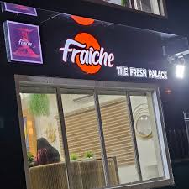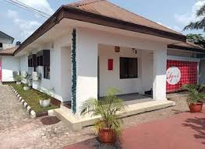

casual Restaurants
Name | Cuisine | Meals | Features | Price
Zillion Restaurants and Catering | Nigerian, Seafood | Lunch, Dinner | Takeout, catering services, outdoor seating | $
Tantalizers Uyo | Fast Food, Nigerian | Breakfast, Lunch, Dinner | Takeout, delivery, drive-thru | $
Mr. Biggs Uyo | Fast Food, Nigerian | Breakfast, Lunch, Dinner | Takeout, delivery, kid-friendly | $

fine dining Restaurants
Name | Cuisine | Meals | Features | Price
Ibom Icon Hotel Restaurant | International, Nigerian | Breakfast, Lunch, Dinner | Fine dining, luxury ambiance, wine selection | $$$
Four Points by Sheraton Dining | International, Nigerian | Breakfast, Lunch, Dinner | Upscale setting, conference dining, bar | $$$
Monty Suites Restaurant | Nigerian, Continental | Breakfast, Lunch, Dinner | Poolside dining, elegant decor, Wi-Fi | $$$

Restaurant Reviews: What Locals Say
- Zillion Restaurants and Catering: “Great seafood and local dishes! The Afang soup is a must-try, but service can be slow during peak hours.” – Local foodie, Eket.
- Tantalizers Uyo: “Perfect for quick meals. Their jollof rice is tasty and affordable, but the place gets crowded at lunch.” – Uyo resident.
- Mr. Biggs Uyo: “Good for families, decent fast food, but customer service needs improvement.” – Uyo local, Tripadvisor review.
- Fraîche Restaurant: “Fresh ingredients and a unique vibe. Their Edikang Ikong is top-notch, and the staff are super friendly.” – Eket visitor.
- Le’Goshen African Dishes Restaurant: “Love the cultural decor and palm wine. Great for group hangouts, but parking is tricky.” – Uyo local.
- The Promise Restaurant: “Amazing seafood platters and live music on weekends. A bit pricey but worth it for the vibe.” – Uyo tourist.
- Ibom Icon Hotel Restaurant: “Luxury dining at its best. Their international menu is great, but it’s expensive.” – Business traveler, Uyo.
- Four Points by Sheraton Dining: “Perfect for upscale dining. The service is excellent, and the food is high quality.” – Ikot Ekpene guest.
- Monty Suites Restaurant: “Elegant setting and delicious continental dishes. Great for special occasions.” – Uyo local.

Recreation & Entertainment
Akwa Ibom State offers a thrilling array of recreational activities and entertainment options that blend natural beauty, cultural immersion, and modern leisure. Visitors can unwind on the pristine sands of Ibeno Beach, Nigeria's longest beach, engaging in swimming, sunbathing, or boat rides along the Atlantic coast. Golf enthusiasts flock to the world-class Ibom Icon Hotel & Golf Resort for 18-hole rounds amid lush greens. Cultural events like the annual New Yam Festival and Ekpe Masquerade performances provide vibrant displays of Ibibio traditions, music, and dance. Historic sites such as the Bridge of No Return in Ikot Abasi, a poignant reminder of the slave trade era, and the tomb of missionary Mary Slessor in Use Ikot Oku offer insightful tours. Natural wonders include the mangrove forests of the Cross River estuary for birdwatching and eco-tours. Entertainment hotspots like Ibom Tropicana feature cinemas, water parks, and amusement rides, perfect for families. Museums such as the Oron Museum showcase ancient artifacts, while ARISE Park in Uyo provides serene walks and picnics. Sports fans enjoy matches at the Godswill Akpabio International Stadium. These diverse pursuits cater to adventure seekers, history buffs, and relaxation lovers, making Akwa Ibom a dynamic destination year-round.

Tourist Attractions Table

water activities
- Swimming and Sunbathing at Ibeno Beach
- Boat Tours in Mangrove Forests
- Speed Boat Tours along the Coast
- Fishing in Coastal Waters

natural wonders
- Ibeno Sandbar Exploration
- Afi Mountain Wildlife Sanctuary Hike

sports, recreation, & spas
- Golfing at Ibom Icon Hotel & Golf Resort
- Soccer Matches at Godswill Akpabio International Stadium
- Spa Relaxation at Ibom Hotel

Arts, Culture, & Entertainment
- Visit Oron Museum
- Ekpe Masquerade Festival
- Entertainment at Ibom Tropicana Centre
- Cultural Show at Raffia City Plaza

Photos of Attractions
Ibeno Beach: Golden sands stretching along the Atlantic, perfect for relaxation.

Oron Museum: Exhibits of ancient artifacts and cultural relics.
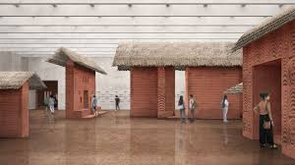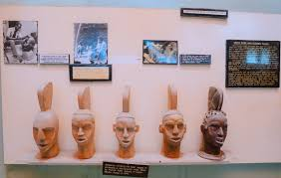

Godswill Akpabio International Stadium: Modern arena hosting thrilling sports events.
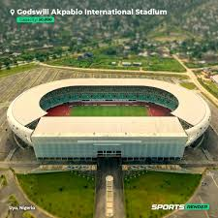
Ibom Tropicana Entertainment Centre: Vibrant water park and cinema complex.
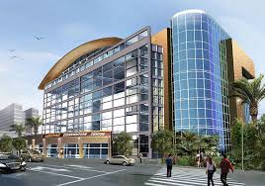
Bridge of No Return: Historic site with somber slave trade history.
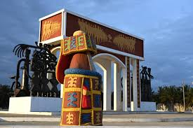

Afi Mountain Wildlife Sanctuary: Lush trails amid diverse wildlife.
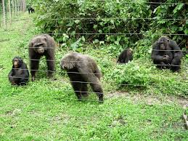

Itinerary

Fun in Akwa ibom: AN Itinerary for adventurous travelers
Akwa Ibom State, with its untamed beaches, dense rainforests, and vibrant cultural undercurrents, is a hidden gem for thrill-seekers. This 4-day itinerary is tailored for adventurous travelers craving adrenaline-pumping activities like coastal speed boating, rainforest treks, quad biking on sandy shores, and cultural immersion with a twist. Base yourself in Uyo, the state's lively capital, for easy access to attractions. Expect a mix of nature's raw power and local hospitality. Total estimated cost per person (excluding flights): NGN 150,000–200,000 (about USD 100–125 at NGN 1,600/USD), covering mid-range lodging, transport, meals, and activities. Pack insect repellent, sturdy shoes, and sunscreen—adventures here are wild!
Day 1: Arrival and Urban Jungle Kickoff – Culture and Speed in Uyo
Kick off your adventure with a pulse-racing welcome to Akwa Ibom's dynamic heart. Arrive at Victor Attah International Airport (Uyo) via Ibom Air from Lagos (NGN 20,000–30,000 one-way). From the airport, hop into a pre-booked taxi (NGN 5,000, 20 minutes) to your base: Monty Suites & Golf (mid-range, NGN 25,000–40,000/night), a 4-star haven with pools and fitness centers, perfect for recharging after flights.
Morning (9 AM–12 PM): Dive into cultural adrenaline at the Oron Museum, a top attraction showcasing Ibibio artifacts and slave trade relics (entry NGN 500). Wander ancient wood carvings and Ekpe masquerade exhibits, feeling the thrill of history's echoes. It's a 1.5-hour drive from Uyo (NGN 10,000 taxi round-trip via AKTC bus alternative at NGN 2,000).
Afternoon (1–5 PM): Amp up the energy with a speed boat tour along Uyo's waterways (NGN 15,000/person, 2 hours via local operators like those at Ibom Marina). Zip through mangroves, spotting wildlife like kingfishers and monkeys—pure aquatic rush!
Evening (6–9 PM): Unwind with entertainment at Ibom Tropicana Centre, another must-see (NGN 5,000 entry). Thrash water slides and catch live cultural dances, blending fun with local vibes. Dinner: Seafood grill at the center (NGN 3,000). Total day cost: NGN 35,000–45,000. Crash at Monty Suites, dreaming of tomorrow's wilds. This day blends heritage thrills with watery excitement, setting an adventurous tone.
(Word count: 178)
Day 2: Coastal Conquest – Beaches and High-Octane Beach Sports at Ibeno
Today, conquer the Atlantic's edge at Ibeno Beach, West Africa's longest stretch of golden sand and a top tourist magnet for daredevils. Fuel up with breakfast at Monty Suites (included), then catch an early AKTC bus from Uyo Park (NGN 2,500, 2 hours) or a chartered taxi (NGN 15,000 round-trip) to Ibeno—scenic roads lined with palms heighten the anticipation.
Morning (8 AM–12 PM): Hit Ibeno Beach (entry NGN 200) for quad biking across dunes (NGN 10,000/30 minutes). Feel the roar of engines as you carve through soft sands, dodging waves—heart-pounding freedom! Follow with horseback riding along the shore (NGN 5,000/hour), galloping amid crashing surf for that epic explorer vibe.
Afternoon (1–5 PM): Explore the Ibeno Sandbar, a natural wonder emerging at low tide (free with beach entry). Wade across the exposed ocean floor, discovering seashells and tidal pools—an adventurous scavenger hunt with a touch of mystery. Lunch: Fresh grilled fish from beach vendors (NGN 2,000).
Evening (6–8 PM): Return to Uyo via bus, stopping for a quick cultural dip at Raffia City Plaza (free entry) for street performances. Dinner: Afang soup at a local spot like Fraîche Restaurant (NGN 4,000). Back at Monty Suites, reflect on the day's salty triumphs. Total day cost: NGN 25,000–35,000. This coastal blitz delivers non-stop action, from motorized mayhem to tidal treks.
(Word count: 162)
Day 3: Rainforest Rampage – Wildlife and Treks at Afi Mountain
Venture into the wild greens of Afi Mountain Wildlife Sanctuary, a premier eco-adventure spot teeming with drills and birds. Start with a hearty hotel breakfast, then arrange a guided transfer (NGN 20,000 taxi, 3 hours from Uyo)—or join a group tour via Rex Clarke Adventures (NGN 25,000 including guide).
Morning (7 AM–12 PM): Embark on a challenging rainforest hike (NGN 3,000 entry + NGN 5,000 guide fee). Trek steep trails amid misty canopies, spotting rare primates and butterflies—pure Indiana Jones immersion. The 5km loop tests endurance with river crossings and viewpoints overlooking valleys.
Afternoon (1–5 PM): Amp the thrill with canopy zip-lining (NGN 15,000, 1 hour if available via local eco-operators) or birdwatching safaris (NGN 4,000). Soar above the treetops or stalk elusive species like the grey parrot—adrenaline meets serenity. Picnic lunch: Packed sandwiches (NGN 1,500).
Evening (6–9 PM): Journey back to Uyo, detouring to Bridge of No Return in Ikot Abasi (NGN 500 entry, en route). This historic slave trade site adds a poignant, reflective adventure layer. Dinner: Seafood platter at The Promise Restaurant (NGN 5,000). Settle into Monty Suites for recovery. Total day cost: NGN 40,000–50,000. From sweat-soaked hikes to aerial whooshes, this day unleashes your inner explorer in nature's fortress.
(Word count: 168)
Day 4: Adrenaline Encore and Departure – Golf, Stadium, and Farewell Thrills
Wrap with high-energy urban adventures before departure, revisiting Uyo's sporting pulse. Breakfast at the hotel, then a short taxi ride (NGN 1,000) to Ibom Icon Hotel & Golf Resort—your adventure pit stop.
Morning (8 AM–12 PM): Tee off at the 18-hole golf course (NGN 20,000 green fee + clubs), weaving through palm-fringed fairways—a strategic thrill blending skill and scenery. It's a top attraction for active souls, with challenging bunkers and ocean breezes.
Afternoon (1–4 PM): Head to Godswill Akpabio International Stadium (NGN 1,000 tour entry) for a behind-the-scenes adrenaline hit—explore the 30,000-seat arena, home to Super Eagles matches, imagining roaring crowds. If timed right, catch a local training session (free viewing).
Evening (5–8 PM): Final fling at ARISE Park (free entry) for trail running and cultural shows—dash through gardens while soaking in masquerade dances. Taxi to the airport (NGN 5,000). Grab dinner en route at Mr. Biggs (NGN 2,500). Depart with stories of conquests. Total day cost: NGN 20,000–30,000 (half-day). This finale mixes sporty challenges with cultural sparks, leaving you buzzing.

Resouces
Tripadvisor
rexclarkeadventures.com
Hotels.ng
Intercity.ng and AKTC.com.ng
Ijeawele.com
akwaibomstate.gov.ng

SWOT Analysis of Tourism in Your Location

Strengths
- List and describe 3-5 strengths your location offers as a tourism destination.

Weaknesses
- List and describe 3-5 weaknesses your location offers as a tourism destination.

Opportunities
- List and describe 3-5 opportunities in your location that could make it a stronger tourism destination.

Threats
- List and describe 3-5 threats that might impact your location’s viability as a tourism destination in the future.

Conclusion
Write a 1–2-page conclusion summarizing your area as a place for tourists to visit. Be sure to include a positive, encouraging description of why travelers would benefit from visiting your area. Why would a visitor choose to visit this location above all others?

